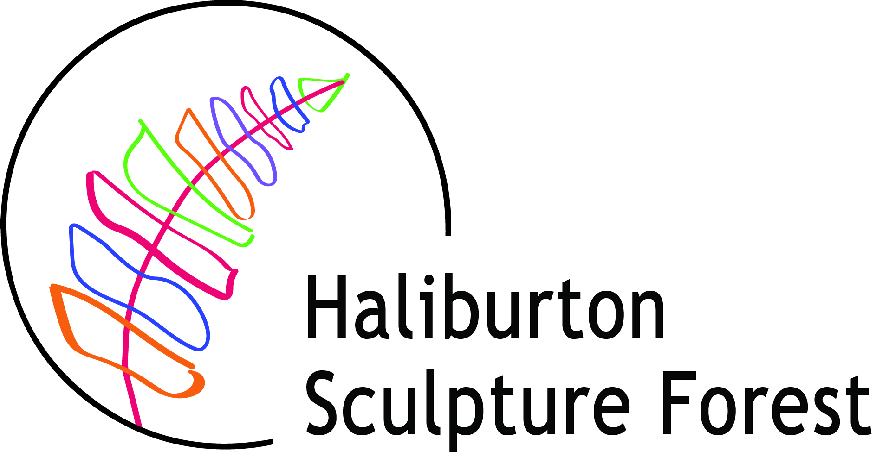

DOWNTOWN HALIBURTON SCULPTURE EXHIBITION 2024
OFFICIAL ENTRY FORM
Deadline for entry – 5:00 PM April 1, 2024.

Artist Name______________________________________________________
Address ________________________________________________________
City______________________________________ Postal Code____________
Phone______________________________ Alt. Phone___________________
Email Address ___________________________________________________
Website ________________________________________________________
Attach a single page artist CV if you wish.
Submission #1
Title____________________________________________________________
Medium_________________________________________________________
Height_______Width_______Depth______ (in inches) Weight (est.)_________ (in lbs.)
Images Info______________________________________________________
Submission #2
Ttile____________________________________________________________
Medium_________________________________________________________
Height_______Width_______Depth_______ (in inches) Weight (est.)_________ (in lbs.)
Images Info_______________________________________________________

Please submit:
- Completed, signed application form, maximum of two entries.
- Images or drawings each labelled with your name and title of work.
- Send images as separate jpeg files
- Sculpture descriptions and narratives (100 words max), including any pertinent information regarding your vision or concept of the work.
- Single page CV (optional).
By completing this Entry Form I acknowledge that:
I have read and agree to the Exhibition Guidelines.
- Images of selected artwork may be used to promote the Downtown Haliburton Sculpture Exhibition without further agreement and without compensation to the artist.

Signature_________________________________ Date________________

DOWNTOWN HALIBURTON SCULPTURE EXHIBITION 2024
SALE INFORMATION

Submission #1 Title____________________________________________
If your work is selected:
Will this sculpture be for sale? Yes No
If yes, what is the retail price of your sculpture? ___________
Please check one box below
I want the retail price included on the information sign attached to the sculpture base plus contact information.
I would prefer “for inquiries about purchase contact the artist at…..”
What email or phone number would you like listed on the sign for prospective purchasers to contact you?
_______________________________________________________

Submission #2 Title____________________________________________
If your work is selected:
Will this sculpture be for sale? Yes No
If yes, what is the retail price of your sculpture? ___________
Please check one box below
I want the retail price included on the information sign attached to the sculpture base plus contact information.
I would prefer “for inquiries about purchase contact the artist at…..”
What email or phone number would you like listed on the sign for prospective purchasers to contact you?
_______________________________________________________

- I understand that I am responsible for all transactions related to the sale of my work and for arranging pick-up and delivery of the work sold at the end of the Exhibition.

Signature_________________________________ Date________________

